**[38] Design NFA Which Accepts ‘BBC’ ‘ C’ And ‘BCAAA’ Over {A,B,C}**

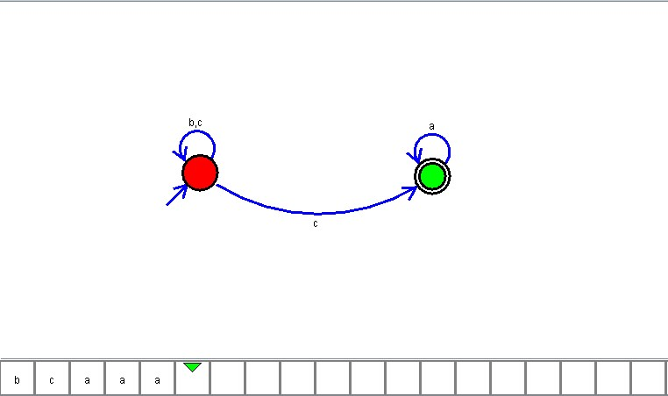

**Result**

The NFA is designed to compute the given strings as input using Simulator